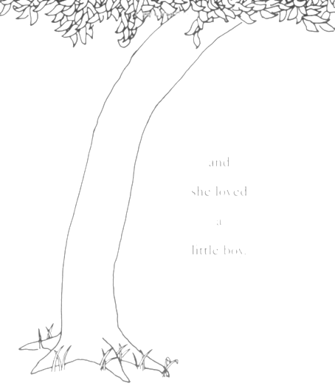

Welcome to the Treehouse!

4/5 Learning Community
P.K. Yonge Developmental Research School

Mrs. Erin Cooke
Mrs. Christina Flake
Ms. Macy Geiger
Mrs. Megan Lanier
Ms. Ella Mohyeddin
Mrs. Sara Montgomery
Mrs. Tara Palmer
Mr. Michael Poole
Ms. Risa Yasukochi

School Website : www.pkyonge.ufl.edu

Treehouse Weebly : www.pkytreehouse.weebly.com

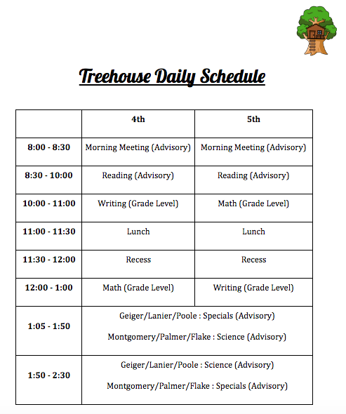

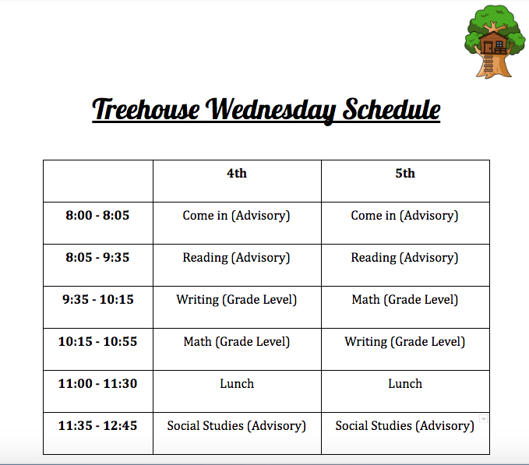
Advisory/Partner Teachers:

Your advisory teacher is the primary contact for your family. Advisory classes will be a combination of 4th and 5th grade students. When students arrive each morning they will meet with their advisory teacher. The advisory class serves as a home base for your child and provides an opportunity for them to participate in Morning Meeting and get oriented for the day. If you have any questions or concerns, always start with your child’s advisory teacher.

Each teacher has a partner teacher that your student will see daily for either math or writing and for science in Quarter 2 and Quarter 4. The graphic below shows how subjects are divided for each teacher and which teacher is partnered with whom:

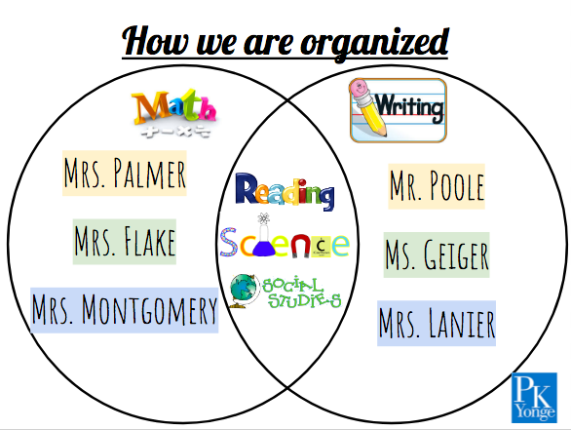

Family/Teacher Communication:

We are committed to maintaining positive and consistent communication between families and teachers. Email is our preferred method of contact. If you have any questions or concerns always start by contacting your child’s advisory teacher. At times, your student will be working with different teachers in the 4/5 Learning Community. So, if another treehouse teacher contacts , please respond directly to them.

General announcements will be sent home in a bi-weekly Treehouse Update via email. Additionally, the Treehouse Calendar and other resources can be found at the Treehouse Weebly: pkytreehouse.weebly.com. If you do not have access to the internet, please inform your child’s advisory teacher as paper copies of the Treehouse Update will be made available.

Standards Based Learning:

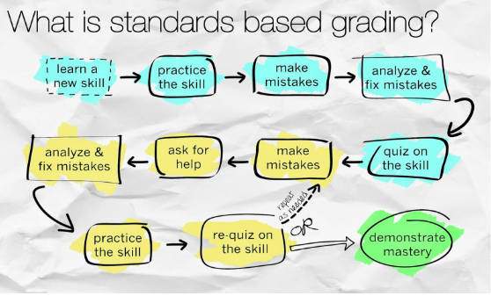

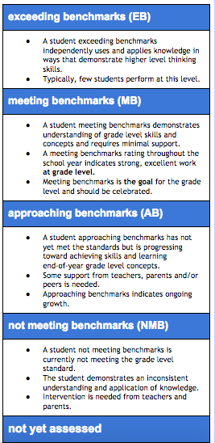
The purpose of Standards Based Learning (SBL) is to provide students, parents, and teachers with more accurate information about students’ progress toward meeting state standards. By monitoring the “student can” statements listed on the report card, families and teachers will have a better understanding of what specific areas a student is doing well with and where there is room for growth.

SBL helps schools target instruction, reinforcement, and enrichment opportunities for all students. Parents also will be more aware of what their children should know and be able to do by the end of each grade level.

Throughout a given unit, student will receive feedback and formative assessment using rubrics. At the end of a unit (in any subject), a summative score will be determined using information from throughout the unit (which may or may not look like a traditional test). Formative assessments are not meant to be reported as a final assessment of student abilities and will not appear in Skyward. The rubrics and formative assessments will give you the clearest picture of your child’s work and progress throughout the year – not what is on Skyward. At the end of each quarter, a benchmark score will be entered into Skyward, which will also be shared on a printed quarterly report card.

If you have questions or need further explanation, please contact your child’s advisory teacher or Mrs. Cooke.
Work at Home

We believe that every student needs different resources and prefers different ways of work to accomplish their goals. Because of this, we believe that having the same assignment sent home to all students to be due at the same time is not effective. To support students in growing on their benchmarks, the following are highly suggested activities to engage in at home :

Reading : read a “just right” text 150 minutes per week
- Extra options:
  - Vocabulary words (sent out on the bi-weekly in the Treehouse Update)
  - Resources on the Treehouse Weebly for supporting readers

Writing : watch our 5-minute video tutorials on the Treehouse Weebly for unit-based suggestions AND have your student share their writing with you by reading it aloud.

Math : Packets will be sent home in the beginning of each unit with worksheets labeled for each unit benchmark. Students choose which pages to work on based upon what benchmark they need to grow on.

Science : try out (optional) Home Investigations that will be sent home in a letter each unit and posted on the Treehouse Weebly.

Work Time:

We are dedicated to helping every student reach mastery in all of their academic and skill standards. We are offering work time every Monday, Tuesday, and Thursday after school from 2:30 – 3:00pm in the 4/5 Learning Community STARTING MONDAY, SEPTEMBER 11th. At the end of each work time, students will be walked to the front circle. Students must be promptly picked up by 3:05. Students not picked up by 3:05 will be sent to the front office or After School if they are actively enrolled.

Student Support and Enrichment

We know that each learner is unique and we strive to provide services for all student’s needs through Differentiated Instruction. Based upon multiple sources of data, students can move into and out of a “tier” to more adequately provide services based upon a need. A “tier” can be a small group, extra conferences, specialized activities, etc. that are centered around a specific student need in relation to the state standards.

Tier 2 support and enrichment services are provided by the classroom teacher and Tier 3 support and enrichment services are provided by the 4/5 Learning Community Leader, Erin Cooke. Families will be notified of their student moving in and/or out of services through a letter home in each quarterly report card.
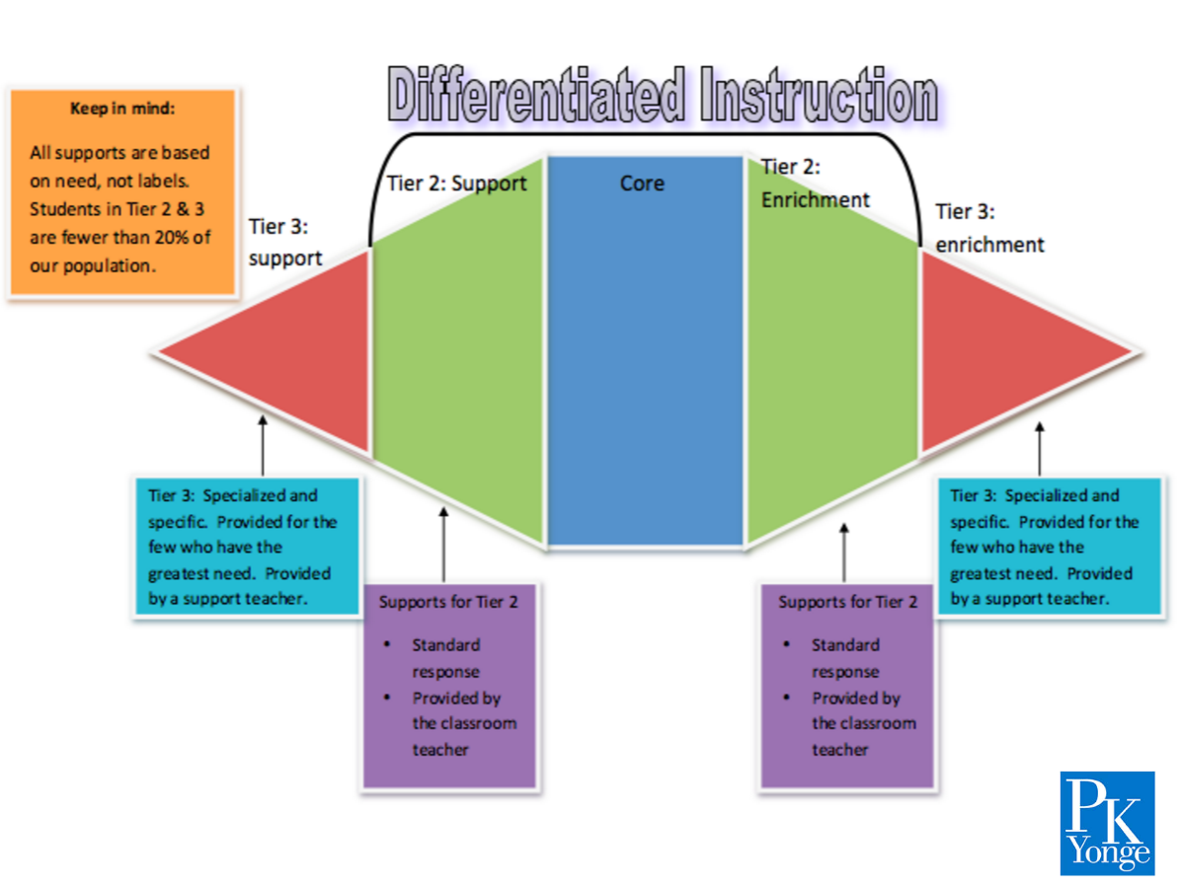
Behavior Expectations

We strive to create a learning environment which provides a safe and relaxed atmosphere, where students feel free to take opportunities to learn and grow. Students are given clear, consistent expectations that remain the same throughout their experience in the Learning Community. In order to provide the students with the excellent educational climate they deserve, we (the students and teachers) have developed the following Treehouse Behavior Expectations that we use throughout the entire school year :
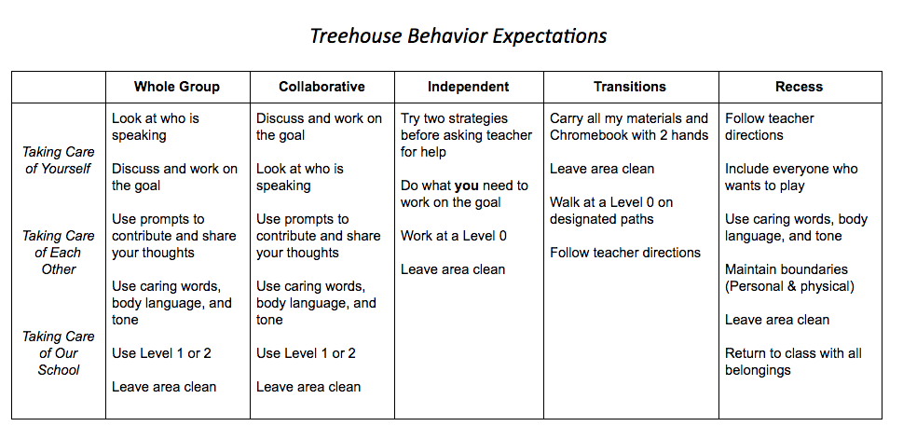

We encourage and promote positive discipline. We build in frequent conversations with students throughout the day about the above behavior expectations and also model how to problem solve issues they may have with peers. On the occasion that we need to intervene, the order of consequential action is as follows:
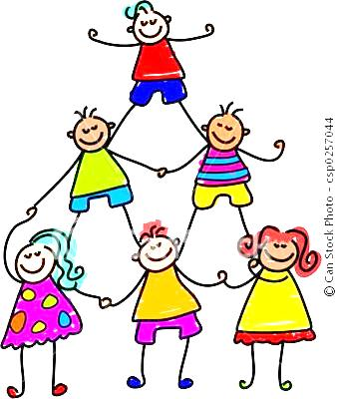
- Warning about behavior is given.
- Student will be asked to fill out a Reflection Sheet, giving him/her an opportunity to examine his/her behavior, its consequences, and a plan for positive change. In the case of repeated Reflection Sheets, families/caregivers may be contacted.
- Student will be moved for time out with another teacher or coach and families/caregivers will be contacted.
- If redirection is still needed, the Elementary Behavior Coach will be contacted, and a referral will be written, in addition to continued contact with families/caregivers.
Student Chromebooks

Each 4th and 5th grade student will be issued a Chromebook to use at school for the whole school year. Page 56 in the Student Code of Conduct outlines fees for damages. Students will have usernames and passwords to log onto their Chromebook and to access Google Suite applications, including Google Classroom. Below, you will see the formulas for student usernames and passwords that will be given out at school.
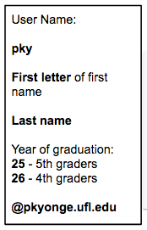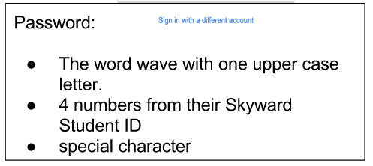

Personal Electronic Devices

We ask families to help enforce the following expectations for our 4th and 5th graders in regards to personal devices:
- Personal devices should be turned off or on silent in your student’s backpack when they arrive to school in the morning.
- Students will not have access to their phones for the entirety of the school day, including morning time, lunch, and recess.

Volunteers

We welcome parent volunteers! Please fill out a volunteer form in the Front Office or request a copy from your child’s advisory teacher if you are interested.

Generally, we need the most help with making copies, fundraising, and planning special events. It is especially helpful if we know set days and times that you are available. Please be sure to pre-register your drivers license with the Front Office at the beginning of the year and to check in and out every time you visit.

Scholastic Book Club

Each year, the 4/5 Learning Community participates with Scholastic Reading Book Club. This is a wonderful program where families can order discounted books while earning points for our 4/5 Community. We then use those points to get free books for our Treehouse Library in the 4/5 Learning Community. We are excited to continue the tradition this school year!
You can order online at scholastic.com/readingclub, where you’ll find a wide selection of quality children’s books that are just right for your child’s reading level and interests. More detailed directions for ordering online are posted below.
Remember, you help our community earn FREE Books and supplies with every order. Thank you for supporting your child’s reading both at home and in the classroom! If you are interested in helping distribute monthly scholastic reading fliers, please contact Mrs. Cooke at ecarlson@pky.ufl.edu ! :)
First Time Ordering Online?
- Go to scholastic.com/readingclub
- Enter our one-time Class Activation Code (PCVYY)
- Shop and submit your child's book order.
- Your books will be delivered directly to the classroom.

Tardies

If your student arrives after 8:05, they are considered tardy. Tardy slips will be written at the Elementary North Lobby Entrance (door facing H-wing) until 8:30.

If your child arrives after 8:30 a.m., your student must go to the Front Office. You may then escort your student to the North or South Lobby Entrance or a member of the school staff will escort your student to the building.

Check-In/Check-Out

If you need to check your student out of school, please go to the Front Office and sign your student out. Mrs. Lisa Sanchez in the front office will call the elementary building and your student will be escorted to the attendance office. Please do not come directly to the elementary building to check out your student. Please allow 10- 15 minutes for the check-out process.

Field Trip
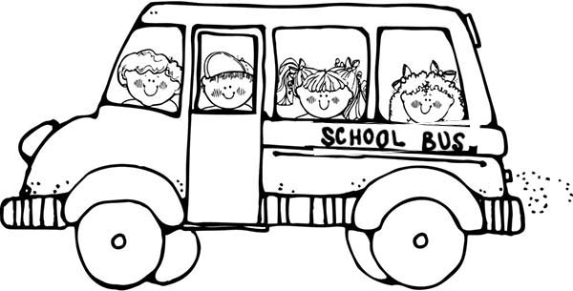
Mark your calendars for our field trip this year!
More information will be available soon.

  - Washington, D.C. – May 2018

Lunch

Students will eat lunch on the south side of the elementary building next to the creek. In the case of inclement weather, we will eat in the cafeteria. Families are welcome to come eat lunch with their student. Please check in at the front office and get a Visitor’s Pass. Families can take only their own child(ren) to eat at the reserved family picnic tables. For safety reasons we cannot allow other students to go eat lunch with your family. During this special family time, students are not permitted to run around or get near the creek.

Birthday Celebrations

Birthday celebrations may only happen during recess on Monday, Tuesdays, Thursdays, and Fridays 11:30-12:00. We ask that birthday treats be brought in for only your student’s advisory class (22 students). Please send the treats in the morning with your child so we can make preparations.

Skyward

PK Yonge uses Skyward as our K-12 communications platform. Skyward contains student records, benchmark scores, contact information, etc. Please be sure to keep contact information current on Skyward as this is the only way for teachers to get in touch with you. This is a great way for the family, the student, and the teacher to work together to ensure a successful school year.

For parent and student access:

- Go online to www.pkyonge.ufl.edu
- Click on the checkmark icon at the top of the page.
- Type in your student or parent Login ID and Password.

Usernames and passwords can be requested in person from the front office. Teachers do not have access to Skyward parent accounts. If you have any questions, please contact Lisa Sanchez in the front office.

Emails

Mrs. Palmer: tpalmer@pky.ufl.edu Mr. Poole: mpoole@pky.ufl.edu
Fundraising Coordinator

Ms. Geiger: mgeiger@pky.ufl.edu Mrs. Flake: cflake@pky.ufl.edu
Patrol Coordinator

Mrs. Lanier: mlanier@pky.ufl.edu Mrs. Montgomery: smontgomery@pky.ufl.edu
Communications Coordinator

Mrs. Cooke: ecooke@pky.ufl.edu
Learning Community Leader & Field Trip Coordinator

